**Steps To Run the Azure Databricks**

**To create a student account, follow these steps:**(https://azure.microsoft.com/en-us/free/students/)

**Once an account is created, we will have access to the following services:**

**Once Databricks are opened, we need to create a workspace:**

**Need to create a workspace with the below details:** **Step-1:**



**Step-2:**

**Step-3:**

**Step-4: Review and create the workspace**



**ADB Workspace Created:**

**As shown below, click on the workspace you've created:**

**It is necessary to create a cluster in order to run the code:**

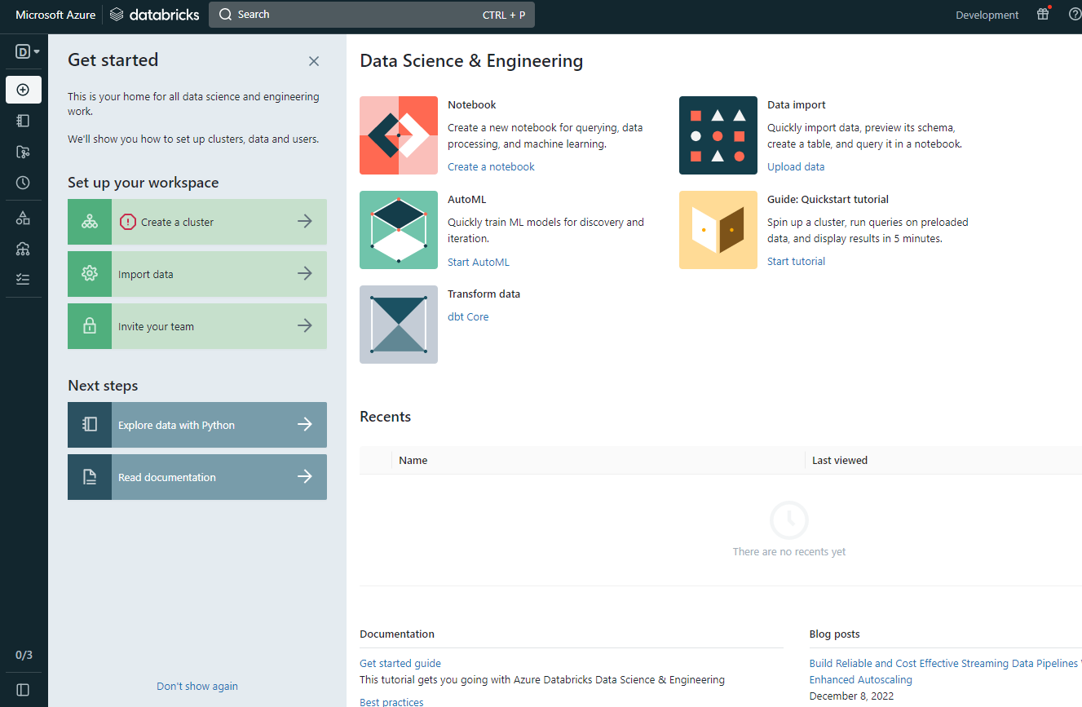



**Create the cluster with below details:**

**Once the cluster has been created, we must create a notebook in which to write our code:**

**

**Write and execute the code that you have created in the above notebook:**

